**Exam 1 Review**

* User’s perspective versus System’s perspective (resource allocator & control program)
* Kernel, system programs versus application programs
  + System programs are associated with OS but are not are necessarily part of the kernel
  + Application programs include all programs not associated with the OS
* Bootstrap program
* User mode versus kernel mode

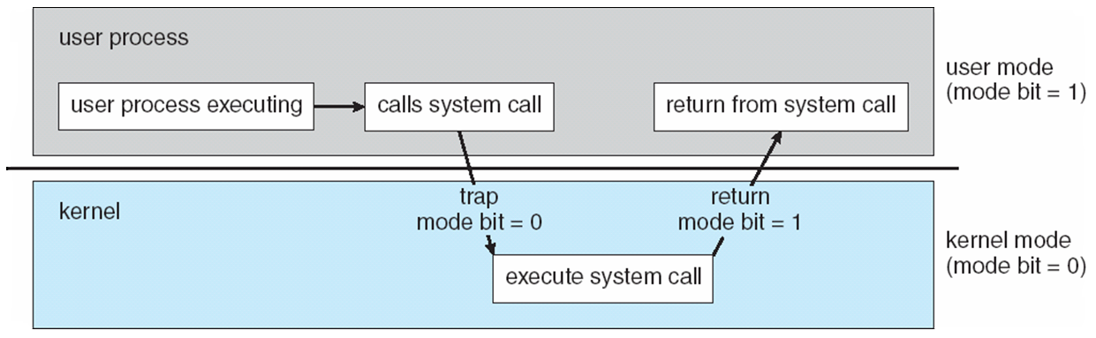

1.6 Which of the following instructions should be privileged?

1. Set value of timer.
2. Read the clock.
3. Clear memory.
4. Issue a trap instruction.
5. Turn off interrupts.
6. Modify entries in device-status table.
7. Switch from user to kernel mode.
8. Access I/O device.

The following operations need to be performed in the privileged mode: (a) Set value of timer, (c) clear memory, (e) turn off interrupts, (f) modify entries in device-status table, (h) access I/O device

* Process Control Block and its usage (CPU switch from to process)

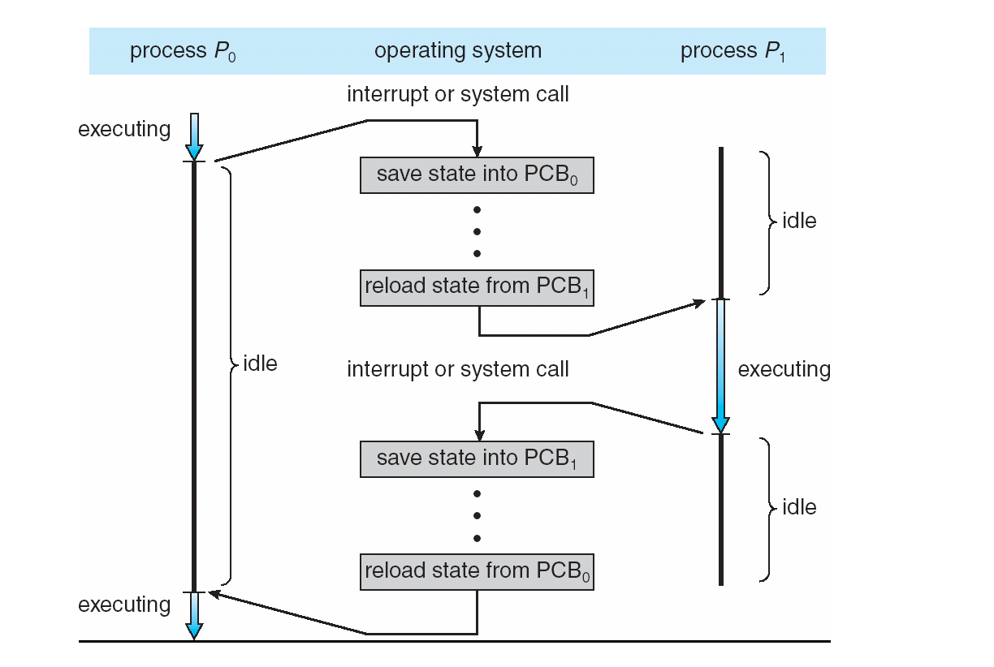

* States of process: new, ready, running, waiting, terminated
* Context switch
* Process scheduling – the queuing mechanism: job queue, ready queue and device queue
* Short-term, medium-term and long-term schedulers
* Buffering – 3 approaches
* Message synchronization – send() and received()
* Zombie, orphan and init processes
* Fork, exec(…), wait(), exit()
* Socket, RPC, ordinary and named pipes
* Bounded capacity, zero capacity, unbounded capacity